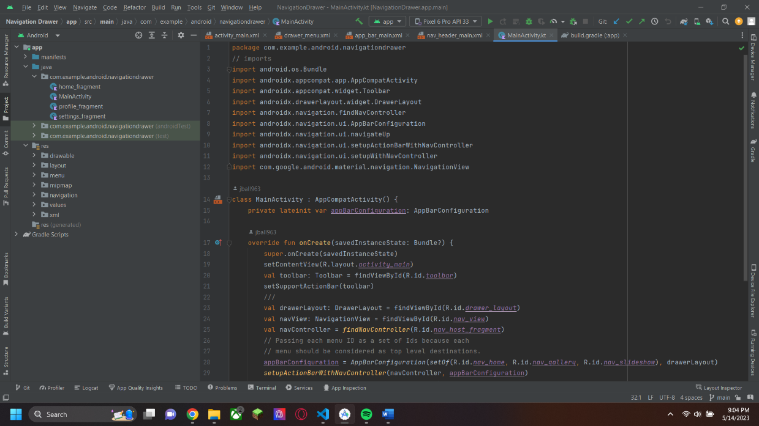

For the main kotlin file of the assignment, I inserted the code that you wanted me to copy. Unfortunately, the code you gave us was riddled with errors, but most of the files on this part could be resolved by quick fix by importing the recommended files

For the mav_header_main.xml file, when you had us make the file, it is attempting to call on set dimen variables which you never had us set in the assignment and we never even learned about in class.

For the app_bar_main.xml, the code also had some errors that I couldn’t find out how to resolve. It seems like the code you gave us calls on some kind of style resource, but again, your instructions never had us make it and I couldn’t figure out how to do it even after several days.

For the drawer_menu.xml file, there are even more errors which I couldn’t resolve. For the drawable resources that are missing, I managed to figure out how to make the files, but I couldn’t find how to make the icons, since you never even taught us what a drawable resource was or how to use them

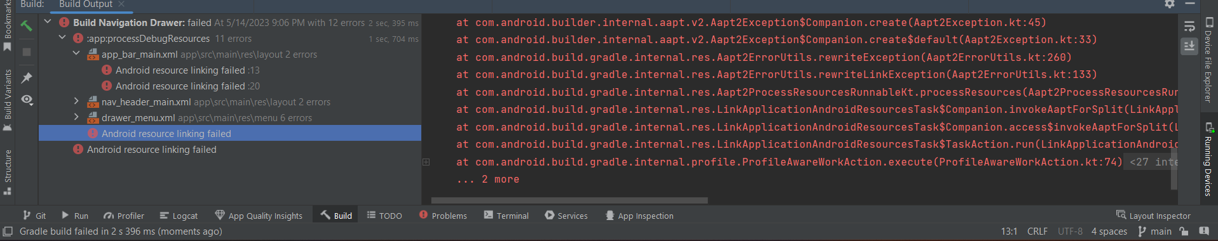

Lastly, with the code you gave us, this is the terminal when I try to run the code after following the instructions. I tried to repeat the instructions multiple times, in fear that what was happening was a result of my mistake, but I could never get the code to work. Even after asking for help like you instructed, I never got a response and even with my own searching, I couldn’t ever figure out how to get the code to look like what you wanted. I even tried to make a new project with the navbar layout, and none of what was included in it was the same that you had us create.